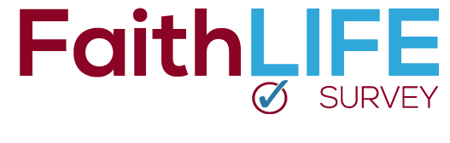
Our church will soon be participating in the FaithLIFE Survey and your participation is very important. This survey will provide valuable information about the faith practices and beliefs of our congregation, and how we can best help you life out your faith in all of life.

When Nehemiah set about to rebuild the walls of Jerusalem, he began with an assessment of the walls.

¹³ I went out through the Valley Gate toward the Jackal Well and the Dung Gate, examining the walls of Jerusalem, which had been broken down, and its gates, which had been destroyed by fire. ¹⁴ Then I moved on toward the Fountain Gate and the King’s Pool, but there was not enough room for my mount to get through; ¹⁵ so I went up the valley by night, examining the wall. Finally, I turned back and reentered through the Valley Gate.
Nehemiah 2

The leadership of our church wants to help you in every way possible to know and follow Christ 24/7. While we are not new to this process, like Nehemiah, we want to get a sense of what work needs to be done, and how to best allocate our resources. In short, this survey will provide us with information about how our congregation is living out their faith outside the walls of this building. More importantly, it will give us some solid direction for how we can help you best.

You will hear more from us about the survey in the coming weeks, but we wanted you to know it is coming and we are excited about this opportunity.

The survey will span three weeks and will begin for <INSERT CHURCH NAME> on <INSERT DATE>

